The Elizabethtown collge wellness center
Anthony Davala, Brian Brennan, and Greyson McDonald
Elizabethtown College, Elizabethtown, PA

Abstract

Due to its current lack of a centralized building for student well being, Elizabethtown College would benefit from the construction of a Wellness Center. The Wellness Center is designed to cater to not only physical needs, but mental and spiritual needs as well. It will do so by providing large athletic areas for training or general exercise, counseling and relaxation rooms for those in need of a person to talk to or a place to relax, and green spaces for meditation or other spiritual needs. The building will be designed to meet LEED certification standards to ensure maximum sustainability by adopting many techniques and strategies to reduce the overall environmental impact. Upon completion, the building would primarily be used by students, but may even be used by nearby residents to provide a source of income for Elizabethtown College.

Introduction

A Wellness Center brings together all of the essentials for a person’s health and well-being under one roof. It can be used in a multitude of ways for a wide breadth of people, which makes it such a good choice to be selected for construction at Elizabethtown College. Traditionally, a “Wellness Center” is a building which primarily serves to prevent sickness and keep health in check. John Whaley Gallup opened in his book Wellness Centers: A Guide for the Design Professional, by saying, “Wellness Centers are facilities that incorporate clinical and fitness components into a comprehensive healthcare center” (3). This proposal aims to provide a service at a much smaller scale, specifically catering to the students of Elizabethtown College, and possibly a few outside residents. The building will likely be much less “health clinic” oriented than most Wellness Centers, due to its decreased size, but will have the means of treatment for physical injury, or other basic needs.

While the Elizabethtown College Wellness Center cannot provide the extensive services of a hospital, the facility goes beyond those services in other ways. Sacred spaces for religious purposes are another component of wellness that will be accepted among all students.

LEED
The most important aspect of the Student Wellness Center is that it is as green as possible. The LEED v4 for new construction and major renovation self-assessment serves as a great tool to ensure that this building is efficient and environmentally friendly. The building was assessed using the fourth version of the LEED assessment check sheet for building and construction, as is the most relevant and up-to-date of the LEED checklists. In order for the Wellness Center to be LEED certified, it must earn at least 40 of the possible 110 points, as well as, pass certain required accreditations. The Student Wellness Center should pass all of the required accreditations on the LEED checklist, such as Pollution Prevention, and Indoor and Outdoor Water use Reduction. Said checklist is divided into eight sections based on similar categories.

The first category pertains to location and transportation. Within this division there are many credits this building should pass. “LEED for Neighborhood Development Location” is the largest of these credits. The Wellness Center should qualify for this credit because it is in a good accessible location and has the potential to be used by members of the Elizabethtown college community, not just students. While it is still up in the air whether or not members of the town will have year-round access, the center should be available to non-students during summer and winter breaks, at the very least. Other credits in this category the Student Wellness Center should qualify for are: “High Priority Site,” “Surrounding Density and Diverse Uses,” “Access to Quality Transit,” “Bicycle Facilities,” “Reduced Parking Footprint,” and “Green Vehicles.” The building has paved paths leading to the entrances, bicycle racks, and is not located directly next to a parking lot. This will promote healthier, greener means of transportation to and from the building. Another credit in this category the building will pass is “Sensitive Land Protection.” The chosen location is not situated in areas considered sensitive areas considering it’s not located in any habitats or farmlands.

The next category pertains to “Sustainable Sites” credits. Within this section, it is unknown whether the building will qualify for the “Site Assessment” accreditation. Credits in the aforementioned category the Student Wellness Center qualifies for are “Open Space,” “Rainwater Management,” “Heat Island Reduction,” and “Light Pollution Reduction.” The building will not serve as a heat island, will incorporate light colors, and also contain many windows for natural light and reduced light pollution. There is also a gutters in place with a rainwater collector and the building will incorporate “gray water” toilets.

“Energy and Atmosphere” themes the next group of LEED credits. “Green Power and Carbon Offsets,” “Demand Response,” and “Energy Metering” are credits the Wellness Center should qualify for. One accreditation consists of 18 credit points, “Optimize Energy Performance.” The building may not qualify for all 18 of these credits, but would at least be suitable for a fraction of them, an estimate is a low of 6 credits. The Student Wellness Center passes these credits because of the green areas designed around the building, such as the garden, and the green roof.

The next section of the LEED checklist is complicated as it revolves around the materials and construction processes. It is for this reason an accurate estimation of the credits passed in the “Materials and Resources” section cannot be completed. As designers, it would be out of the group’s complete control, but these credits would be strongly advocated and pushed for.

“Indoor Environmental Quality,” however, is under the control of the designers. The Student Wellness Center will pass the “Enhanced Indoor Air Quality,” “Thermal Comfort,” “Interior Lighting,” and “Daylight” credits. The main features to comply with the accreditations are the skylights and northern facing windows for large amounts of natural light, and LED back-up lights. Also the building is insulated and will be kept at comfortable temperatures; this will also use the help of geothermal heating. Also, no tobacco/smoking areas will be strongly enforced, as it is a building revolving around health.

The final two sections: “Innovation” and “Regional Priority” are also up in the air, and cannot be accurately assessed by the designers, as they do not have the knowledge the properly perform the assessment. Especially the “Regional Priority” credits. However, “Innovation” is a credit worth 5 points, and the designers feel that the building should at least qualify for some of these credits, but cannot make an accurate estimate.

Features

The Wellness Center is designed to not only satisfy LEED requirements, but also bring together Elizabethtown College’s community multiple ways. With a unique design, the Wellness Center is divided into three sections: Mind, Body, and Spirit. These three pillars aim to fulfill all student’s and faculty’s wellness needs.

The Wellness Center’s Mind section is focused on ensuring students have the environment to relieve any stress through relaxing, studying, and/or meditating. Located on the second floor, the Mind section has 18 divided up for coaches’ offices, study rooms, counseling/ therapy offices, and Wellness Office (The Well). The rooms, aside from specific faculty, can be utilized for any student and/or faculty member. Much like the study rooms in the High Library, it’s a first come, first serve basis.

The Body section of the Wellness Center is for anyone who wishes to relief stress physically. A weight room, basketball court, track, and all OSA activities serve for the stress relief college students need.

The gym has a college regulated basketball court that will the basketball team’s new home. This will be allow more time for students to use the basketball courts for their own pleasure. The track is scaled down to fit within the room, but it takes 11.5 laps to complete one mile. This track is non-competitive; it gives students and faculty a place to jog during cold winter months, when it’s raining, or just another place to run. The gym will have a compressible floor, much like in a weight room, around the outside and inside of the track, up to the wood floor the basketball court will be on. This will let students to utilize the empty space with any activity they choose to do such as hacky sack, juggle a soccer ball, throw a football, Frisbee, etc.

The weight room and OSA activates are located on the eastern side of the building. Here, the weight room gives athletes and other students another choice to work out. Since, OSA runs many activates, athletic and non athletic, they are given two rooms to use for any activity.

During a tour with Coach Schlosser, he stated the new facility needs weight rooms. We have added six locker rooms to satisfy the lack of athletic storage space. The Wellness Center has four bathrooms with showers.

The Wellness Center aims to fulfill the spiritual needs of the individual. The main feature of the Spirit section is the nondenominational prayer room, which aims to provide a spiritual space to any person both religious and nonreligious. The space will contain various religious texts and objects, encouraging people from all backgrounds to utilize the room. Apart from this, the Wellness Center also has designated “green spaces” where a person can go to if they find themselves in need of rest or relaxation or meditation. The point of the Spiritual section of the building is to give people of any background a place to explore the spiritual nature of one’s self.

In addition, the Wellness Center has a few design features to accommodate anyone who enters. There is an elevator for the handicap to reach the second floor. The 2nd floor’s gym viewing floor will have tables and chairs set up for anyone who wants to watch the basketball game and still do some work. There will also be couches and lounge chairs set up for additional relaxation areas. Brita water stations are accessible at many locations in the building. A Health Food “Bar” is to be implemented on the first floor on the western side of the building. This is also the location of the physical therapy and medical room.

Conclusion

The Elizabethtown College Wellness Center will bring together all the physical fitness aspects of a gym while providing the mental and spiritual services that are important for the well being of a college student or faculty member. This proposed design is an appropriate fit for the college based on its accessible location as well as its sustainability. The building will serve as a student hub apart from the Brossman Student Commons, a new place where students and faculty alike can unwind after work or classes and keep in good health.

The Wellness Center has the capability to serve to a wide variety of needs, mental, physical, spiritual, or otherwise. It is able to do so by providing a multitude of services, from gymnasiums and health food concessions to counseling services and nondenominational prayer rooms. The usefulness of the building cements the fact that the Elizabethtown College Wellness Center is a great investment, and has almost limitless applications.

Appendix A – Site Plan
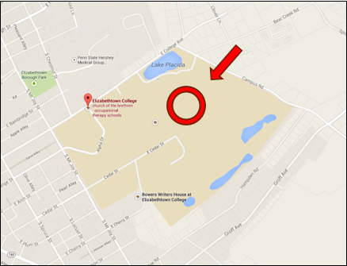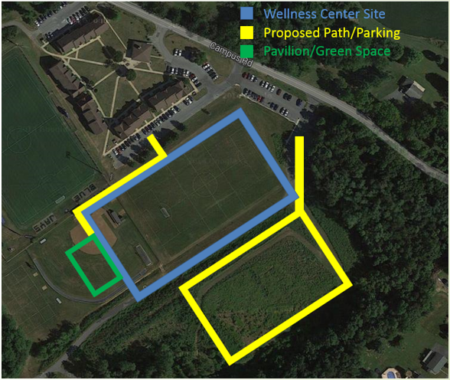
Appendix B – Building Elevations

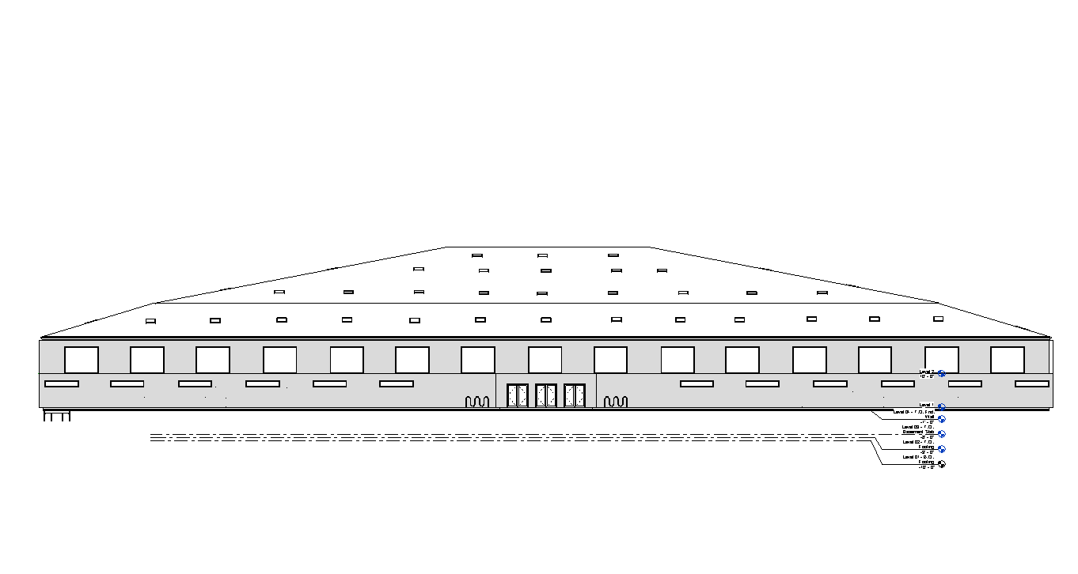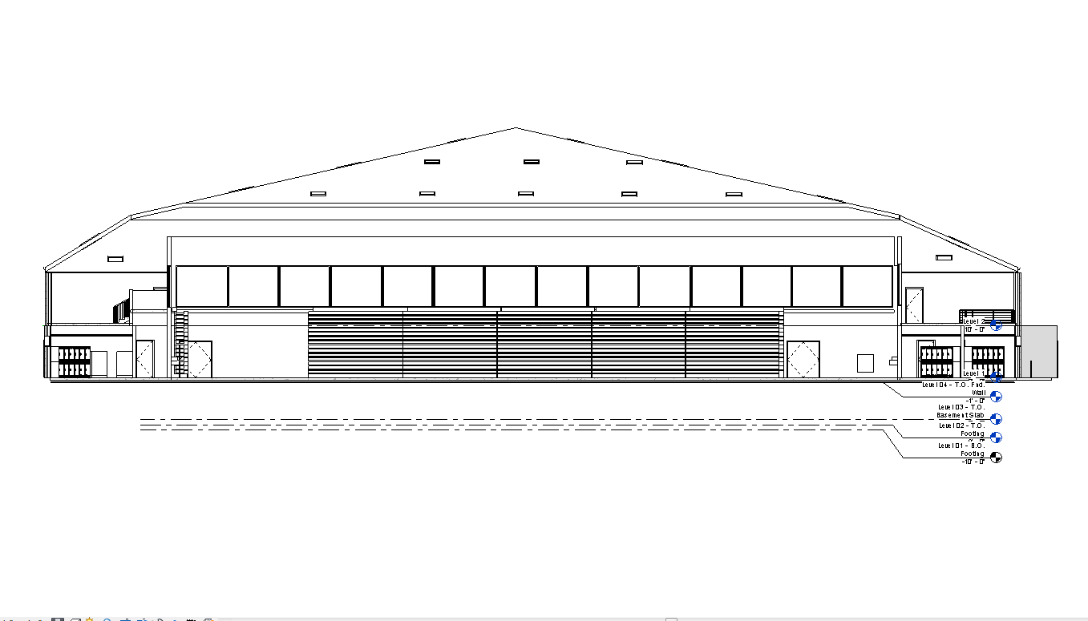

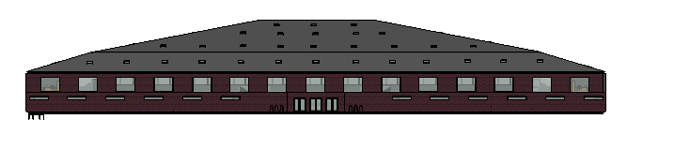

North
East
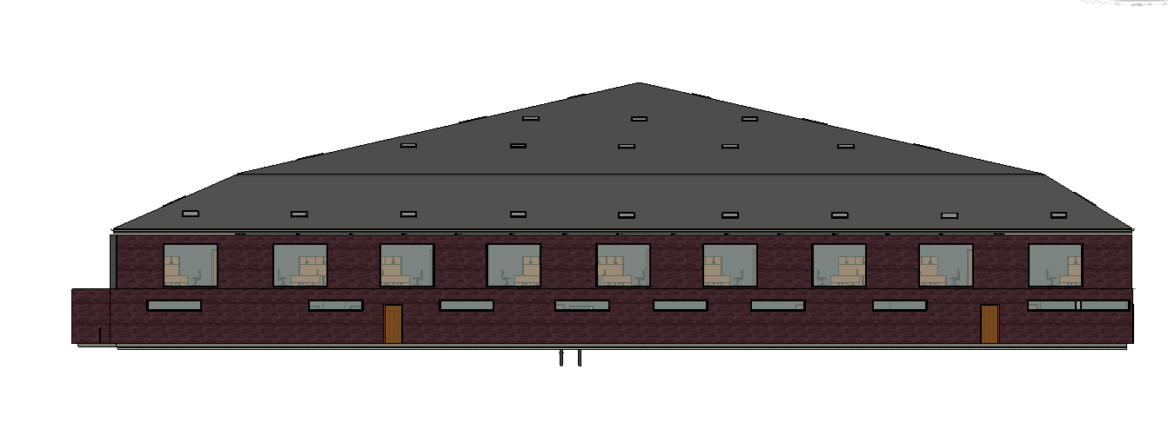South
West
Total Elevation: 49 feet
Appendix C – Floor Plans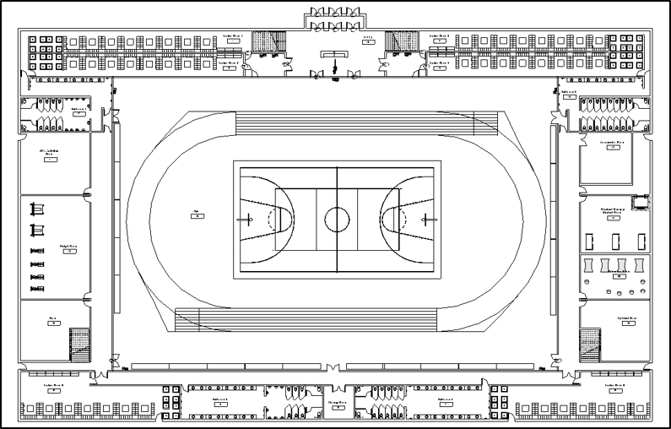
1st Floor

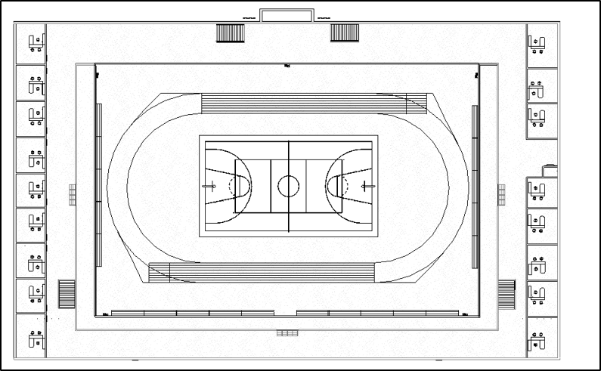
2nd Floor

Appendix D – Cross-Sections and Details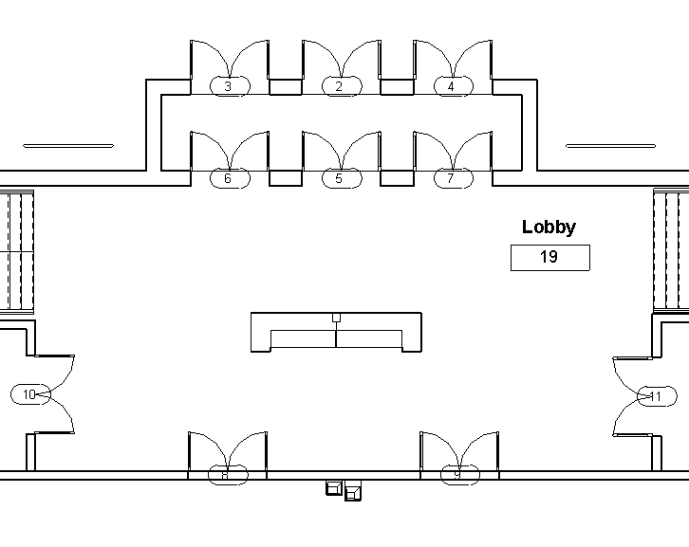Lobby

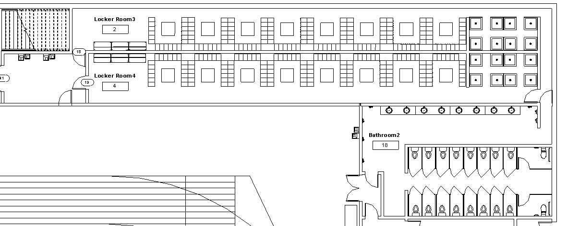
Locker Rooms

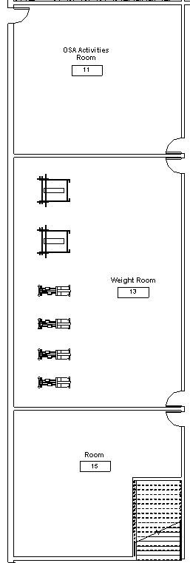
Weight Room/ OSA room

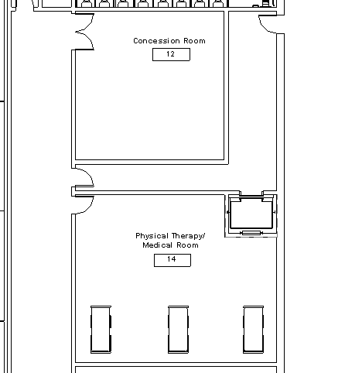
Concessions and Physical Therapy Rooms
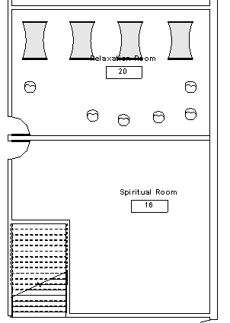

Prayer Room/Relaxation Room

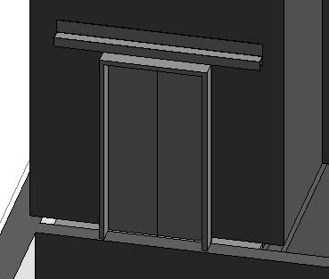

Elevator
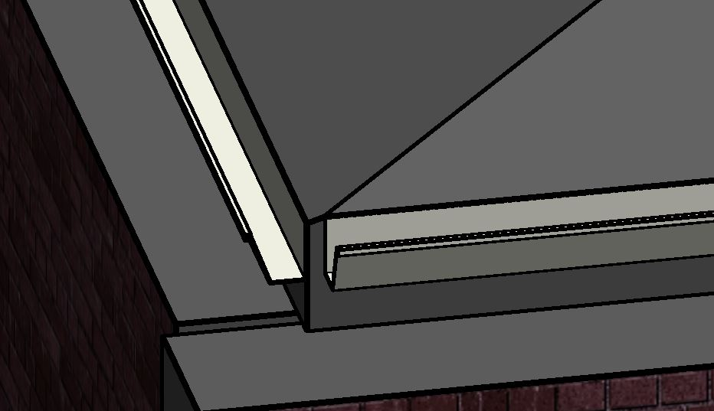

Gutter System

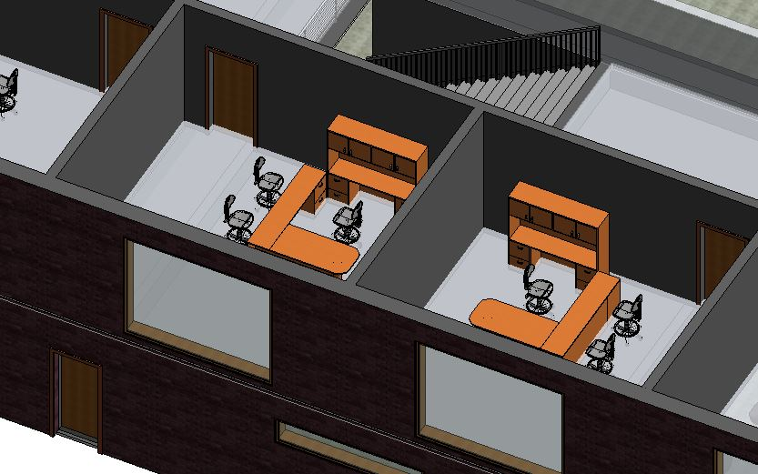

Offices
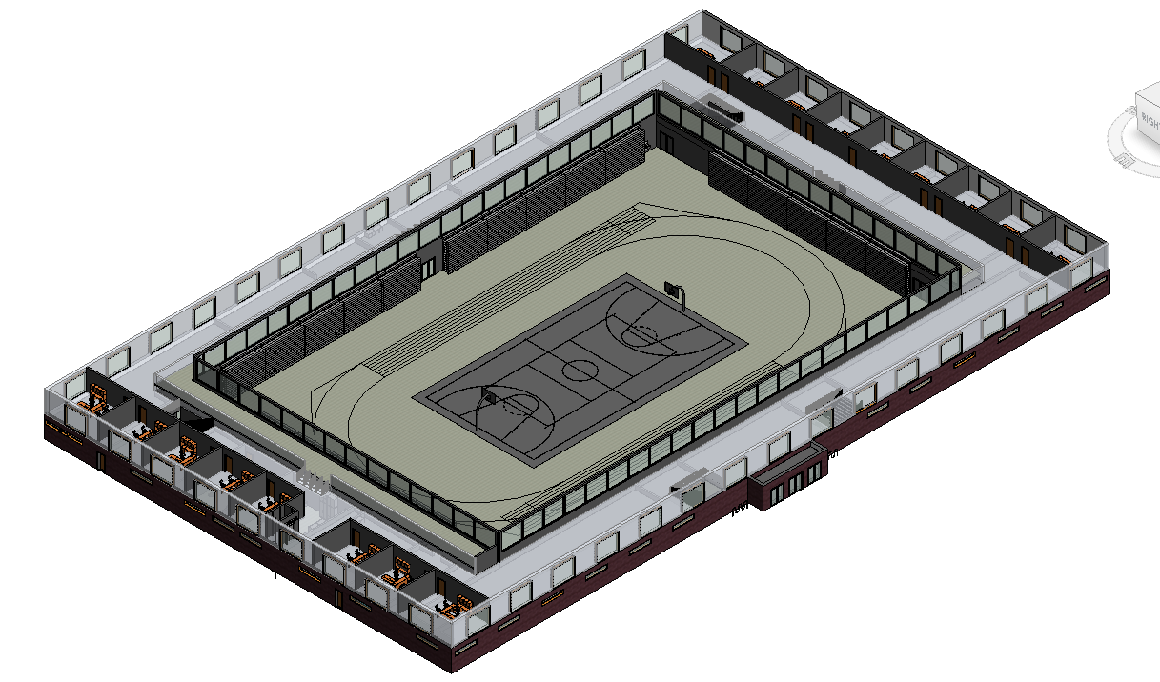

Isometric View Building Layout

Appendix E – References

Wellness Center Reference Page

Gallup, Joan Whaley. Wellness Centers: A Guide for the Design Professional. New York: Wiley, 1999. Print.

